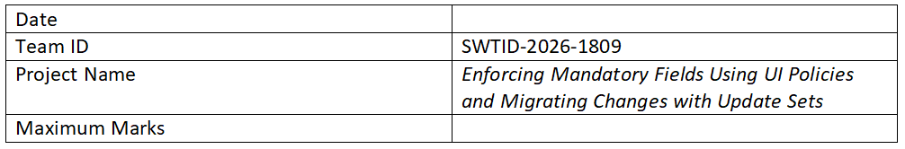

Project Design Phase-II

Solution Requirements (Functional & Non-functional)
Project Title: Enforcing Mandatory Fields Using UI Policies and Migrating Changes with Update Sets

Functional Requirements
Following are the functional requirements of the proposed solution.
FR No. | Functional Requirement (Epic) | Sub Requirement (Story / Sub-Task)
FR-1 | Form Field Enforcement | Mandatory fields enforced using UI Policies
FR-1 | Form Field Enforcement | Dynamic field visibility and requirement conditions
FR-2 | UI Policy Management | Create and configure UI Policies
FR-2 | UI Policy Management | Apply UI Policies on forms
FR-3 | Client-side Validation | Use Client Scripts for additional validation
FR-4 | Update Set Management | Create and capture changes in Update Sets
FR-4 | Update Set Management | Migrate Update Sets across instances
FR-5 | Data Integrity | Ensure mandatory data is captured before submission

Non-functional Requirements
Following are the non-functional requirements of the proposed solution.
NFR No. | Non-Functional Requirement | Description
NFR-1 | Usability | Easy-to-use ServiceNow forms with clear mandatory indicators
NFR-2 | Security | Role-based access control and secure data handling
NFR-3 | Reliability | Consistent enforcement of UI policies across forms
NFR-4 | Performance | Optimized scripts to reduce load time
NFR-5 | Availability | High availability through ServiceNow cloud
NFR-6 | Scalability | Supports increasing number of users and records

